

**Access Statement for**

**Boughton House**

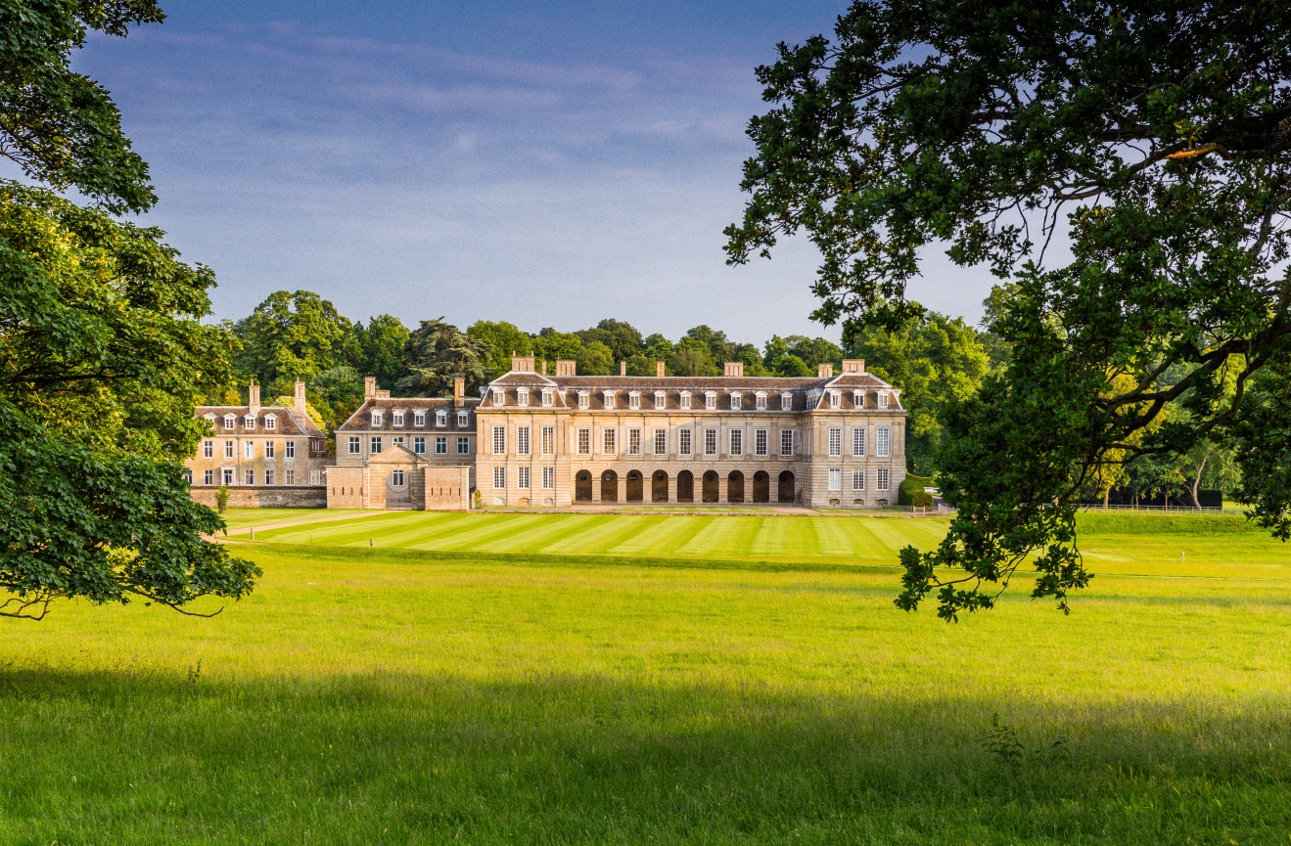

This access statement does not contain personal opinions as to our suitability for those with disabilities, but aims to accurately describe the facilities and services that we offer all our visitors.

**Contents**

Introduction 3

Pre-arrival 4

Car parking and arrival 4

The Great Hall Tour 6

Coach House 7

Public Toilets 7

Reception 9

Book Shop and Gift Shop 10

Tea Room 11

Grounds and Gardens 12

Tapestry Suite 13

Additional Information 14

Feedback and Contact Details 14

**Introduction**

Located in Geddington, Northamptonshire, Boughton is one of Britain’s grandest and best-preserved stately homes. As well as the splendours of the House, you can also enjoy the 18th-century landscaped gardens, the woodlands and a grand country park.

Boughton House itself is located on level ground however there is a gradual inclined slope on the approach to the grounds and gardens.

Boughton also offers several exhibition spaces including the Coach House, located in the Stable Yard, and an exhibition on Handel located within the Unfinished Wing of the House.

If we do not cover your access requirement in this document, please do not hesitate to contact us on 01536 515 731 or email [info@boughtonhouse.co.uk](mailto:info@boughtonhouse.co.uk) and we will be happy to discuss your needs.

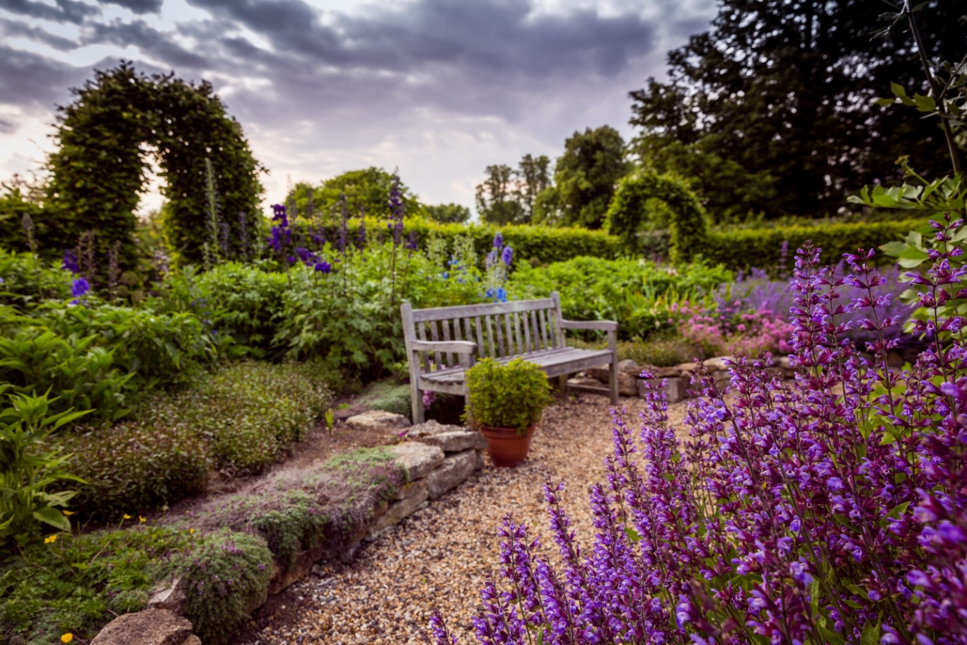

**Pre-Arrival**

**By car**

* For full details and maps of how to reach us please see the [Find Us](http://www.boughtonhouse.co.uk/contact-us/find-us/) section of our website. Alternatively, you can plan your journey by car or public transport using [www.transportdirect.info](http://www.transportdirect.info). Simply enter our postcode NN14 1BJ to get directions.
* The postcode given is for the full estate surrounding Boughton House and therefore not all Satellite Navigation systems will be accurate. We recommend using the directions and google map from the [website](http://www.boughtonhouse.co.uk/contact-us/find-us/) for the most accurate route.

**By rail and taxi**

* The nearest railway station is Kettering, which is approximately seven miles away. Taxis are available at the station. If you require an accessible taxi you can book this in advance. We would recommend KLM taxis who can be contacted on 01536 310123.

**Public transport**

* There is no scheduled public transport route to Boughton House due to its rural location.

**Car Parking and Arrival**

* Parking is available free of charge on site at a distance of 75 meters (246ft) from the Stable Yard. The Stable Yard includes an accessible WC, the Gift Shop, the Reception, the Tea Rooms, Tapestry Suite and Coach House.
* There are 8 blue badge spaces available in the car park.
* People may be dropped at the entrance to the Stable Yard for easier access. We then ask that cars are then parked in the main car park.
* The surface from the car park to the main accessible entrance is paved with a light gravel top that does not impede wheelchair access. However, there is a small declining slope from car park to the Stable Yard and an incline on the route to the accessible entrance on the West Front of the main House.
* If notified, a member of staff will normally be available to direct or if required escort a visitor to the accessible entrance on the West Front and open the doors. The door measures 3 ft 10 inches (1.16 meters) wide and is a locked manual door which opens inwards and can only be opened from inside the House by a member of staff.
* Most areas surrounding the entrance to the House itself and the Stable Yard area, which includes the Gift Shop, Tea Room and Reception, are paved with a very small layer of granite chippings that do not impeded wheelchair mobility, or cobbled.

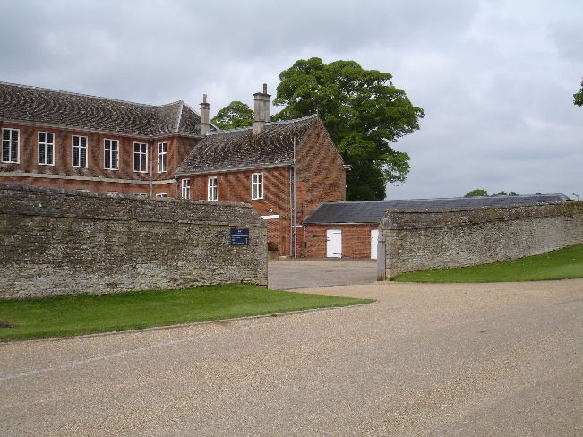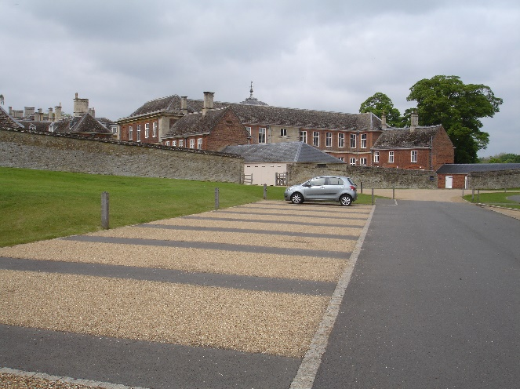

Stable Yard entrance

Blue Badge car parking bays

**The Great Hall Tour**

* The Great Hall Tour is the standard tour offered at Boughton House covering 10 rooms on the ground floor of the house which date from 1528 onwards.
* The Great Hall Tour is accessible for wheelchairs via an entrance on the West Front measuring 3 feet 10 inches (1.16 meters) wide. The doors to this entrance are manual and open inwards. A member of staff will be present to open the doors for you at your allocated tour time.
* The State Rooms Tour and Beds, Books and Beyond are additional tours offered at Boughton House. Both additional tours include several sets of stairs and are therefore not fully accessible. All tours are guided and last approximately one hour.
* All tours of the House have a “shepherd” – a member of staff who is equipped with a radio to contact the office should any member of the tour group need any form of assistance at any point.

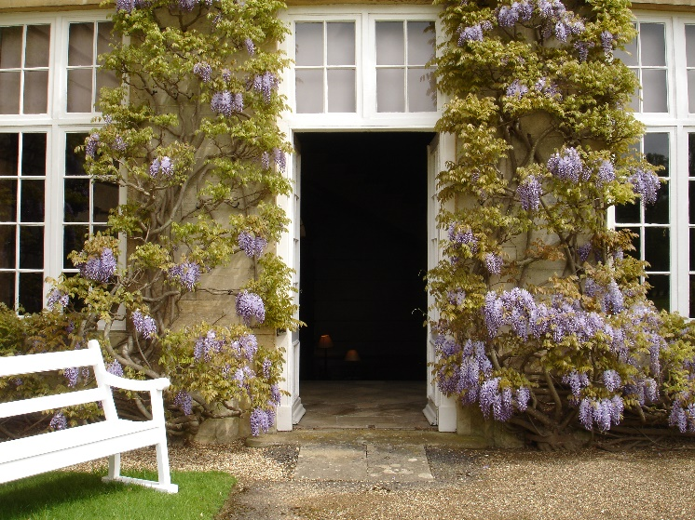

The accessible entrance to the property located on the West Front

**Coach House**

* The entrance to the Coach House measures 4 foot 7 inches (1.39 meters) in width.
* The Coach House, which also dates from 1695, has cobbled flooring which is uneven throughout.
* The Coach House is an exhibition space located in the Stable Yard with information on the gardens and grounds and is also home to a coach built in 1830.

The Coach House entrance and cobbled flooring

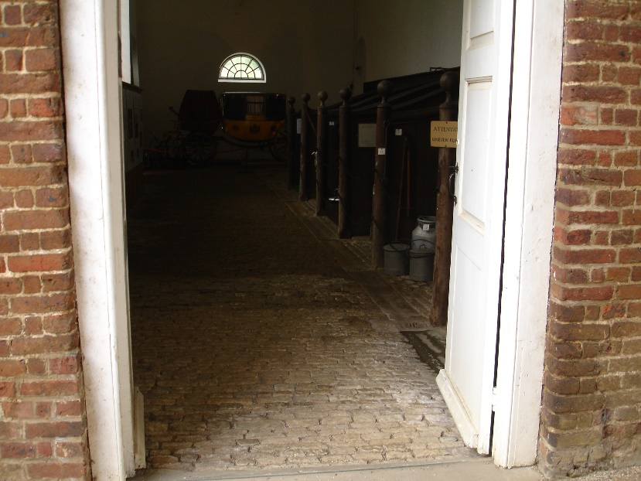

**Public Toilets**

* There is an accessible unisex toilet located alongside the main WCs in the Stable Yard.
* There is cobbled flooring before a tiled ramp leading up to the accessible WC.
* The width of the door to the WC is 2 ft 11 inches (0.88 meters). There is a clear space for a wheelchair to the left hand side of the WC measuring at a width of 2 ft 4 inches (0.71 meters). The height of the WC from floor to seat is 1 ft 5 inches (0.43 meters).
* There is one adjustable handrail to the left hand side of the WC and one wall mounted handrail to the right hand side of the WC.
* In case of a fire in the House, modern internal sounders will activate and alarm emergency a loud air raid siren is sounded. If assistance is needed, guests can activate an emergency call system via a red alarm cord installed in the disabled WC.
* 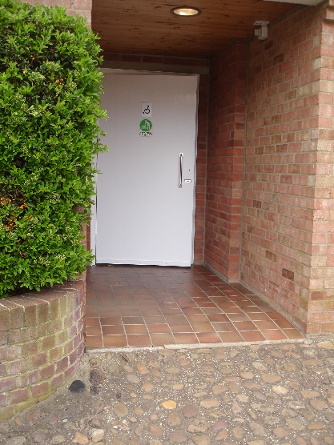The WC is lit using spotlights. The floor is level inside the WC and surfaced with tiles. The taps on the sink are traditional crosshead taps.

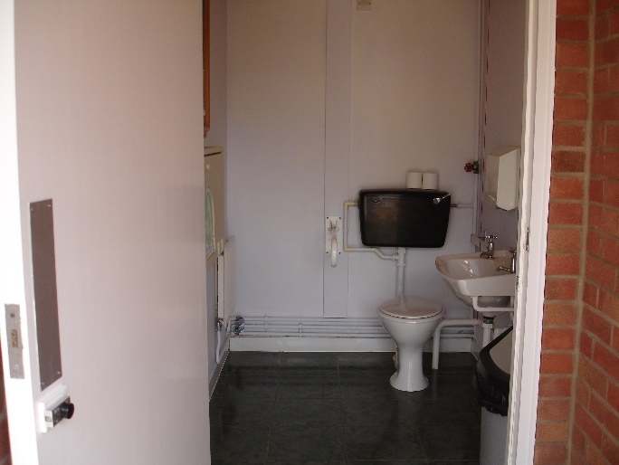

Interior of accessible WC

Accessible WC entrance

Reception

* The Reception is located in the Stable Yard approximately 100 meters (328ft) from the car park. There is a small step measuring 4.5 inches (0.11 meters) at the entrance to the reception. A ramp can be brought over from the Book Shop or alternatively staff are more than happy to step outside or come to the Gift Shop should this be more convenient.

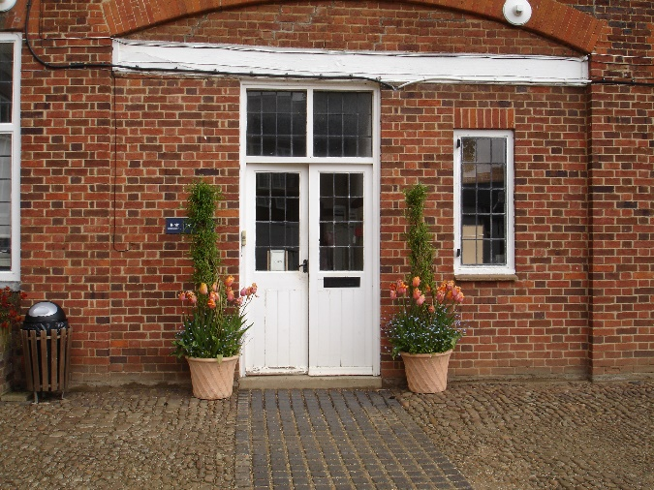

Reception entrance

**Book Shop and Gift Shop**

* During public opening times (Easter weekend and August) tickets are sold in the Gift Shop which is located in the Stable Yard.
* There is some cobbled paving leading to the entrance of the Gift Shop as is shown in the photograph below. The width of the open doorway to the Gift Shop is 4 ft 4 inches (1.32 meters). There is tiled level flooring throughout the Gift Shop. The narrowest space within the Gift Shop is 3 ft 4 inches (1 meter) wide.
* Display racks are located at various heights as shown in the images below but staff can provide assistance should anything from higher shelves. Unfortunately we are unable to provide a hearing loop or low counter area. No background music is played in the Gift Shop.
* A small Book Shop is also located in the Stable Yard and is accessible via a small ramp.

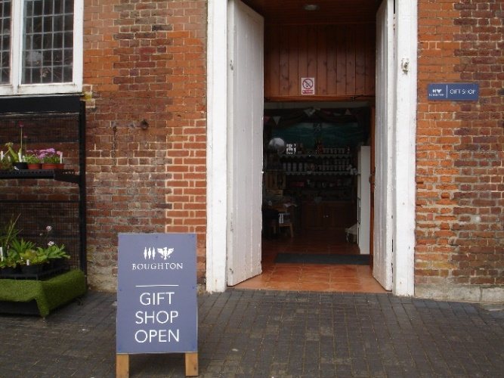

Gift Shop entrance

Book Shop entrance

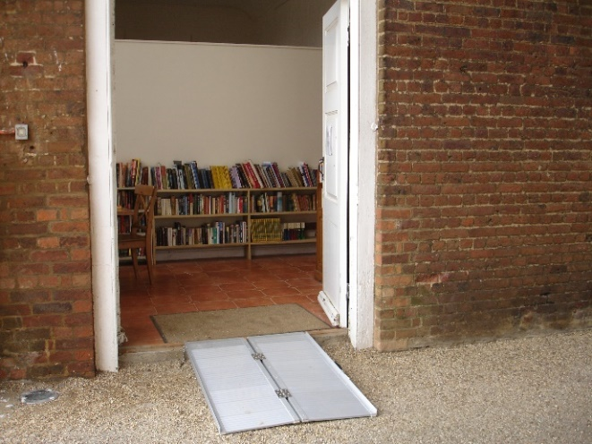

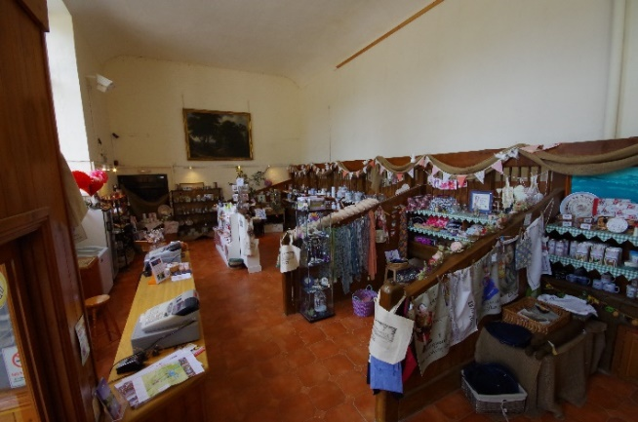

Gift Shop interior

**Tea Room**

* The Tea Room is located in the Stable Yard approximately 50 meters (164 ft) from the Gift Shop and Reception. There is a small ramp leading up to the Tea Room as is shown in the image below.
* The door width when open is 4 ft 6 inches (1.37 meters). The Tea Room floor is tiled and level throughout.
* The tables in the Tea Room are low tables with a height of 2 ft 1 inch (0.63 meters) underneath the tables. All chairs are standard dining chairs with no arms.
* The Tea Room is well lit via large halogen lights and large windows.
* Allergy information is available for all items on the menu. Dietary requirements can be specifically catered for if advance notice is given.
* The service offered in the Tea Room is self-service and is paid for at the counter. Assistance can be given upon request.
* Crockery and tables contrast in colour.
* The nearest WCs, including an accessible WC, are located approximately 75 meters (246ft) away in the Stable Yard.

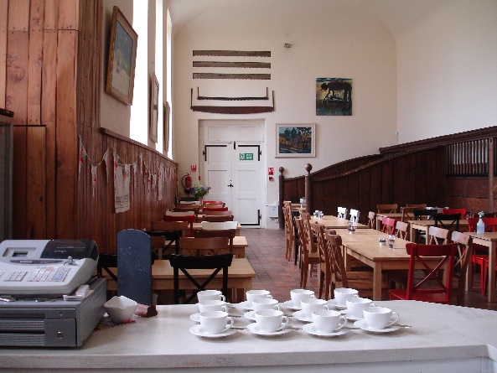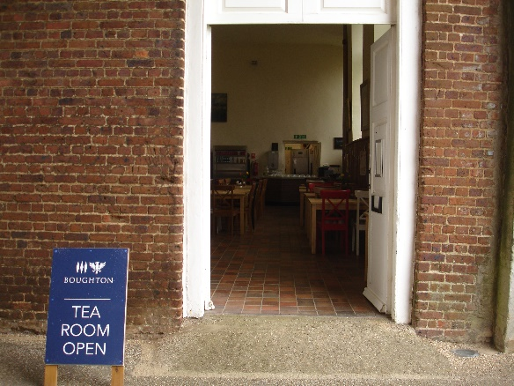

Tea Room interior

Tea Room entrance

Grounds and Gardens

* There is a footpath that covers general views of the landscape and the Walled Garden. The footpath is even, however, there are steep inclines at some points on the suggested route. This footpath is 4 ft 5 inches (1.34 meters) wide at its narrowest point and is covered with light gravel. Other areas of the gardens and landscape are open to the public, but there is no footpath and these areas are grassed.
* The entrance to the Walled Garden is 3ft 10 inches (1.17 meters) wide. The narrowest point on the footpath within the walled gardens is approximately 3 ft 2 inches (0.97 meters).
* Benches are available along the footpath and within the garden, although they are not based at regular intervals.

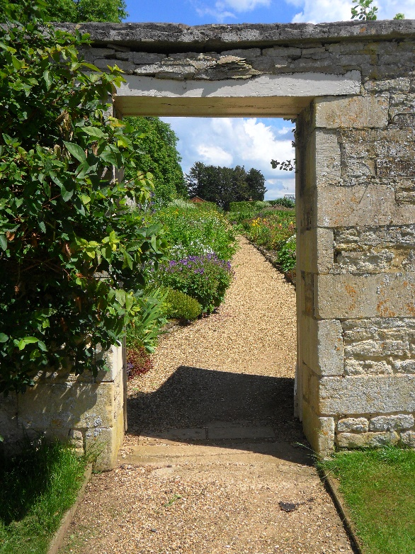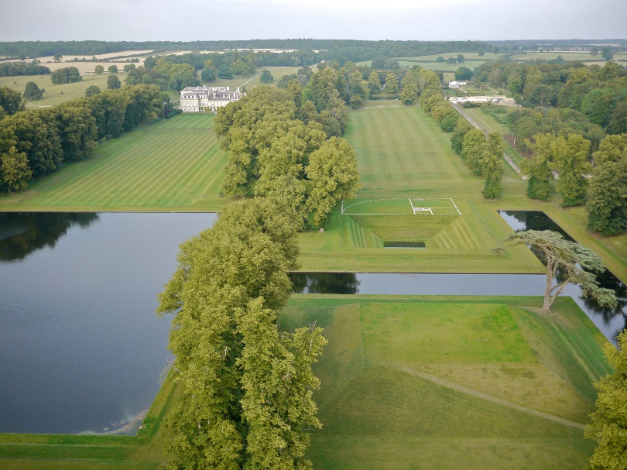

Ariel view of grounds

Entrance to Walled Garden

Tapestry Suite

* The Tapestry Suite is a newly renovated function suite located in the Stable Yard available for hire for corporate events, luncheons, meetings, private events, parties and weddings. The Tapestry Suite holds up to 120 people including staff and is fully accessible via a lift located in the Book Shop.
* There is one accessible WC located in the Tapestry Suite. The width of the door to the WC is 2 foot 3 inches (0.68 meters). There is a clear space for a wheelchair to the right hand side of the WC measuring at a width of 2 foot 3 inches. The height of the WC from floor to seat is 1 foot 6 inches (0.45 meters). There is one adjustable handrail to the right hand side of the WC and one wall mounted handrail to the left hand side of the WC. Hand rails are also located on the door and either side of the sink.
* The Tapestry Suite itself has wooden flooring and is lit via brass branch lights and brass wall lights. The bar and hallway is carpeted and lit with spotlights, brass wall lights and brass branch lights.

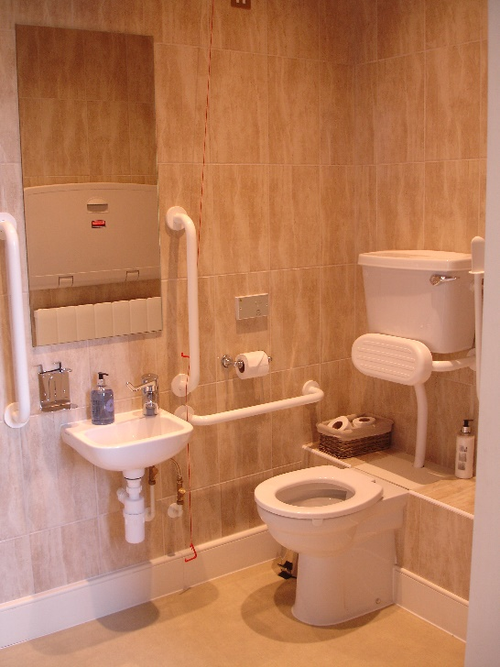

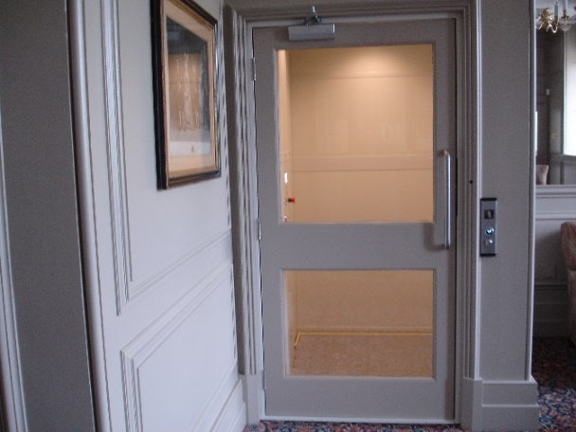

Tapestry Suite lift

Accessible WC in Tapestry Suite

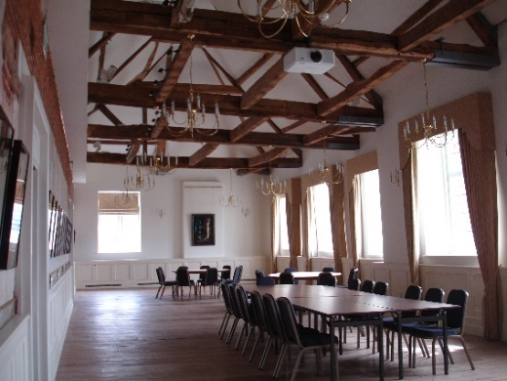

Tapestry Suite interior

Additional Information

* Assistance dogs are welcome and water can be provided upon request.
* We have two manual wheelchairs available for use in the house should you require one during your visit.
* Our local taxi service KLM Taxis provide accessible taxis for those with manual wheelchairs. Unfortunately they are unable to provide accessible taxis for electronic wheelchairs.

Feedback & Contact Details

We welcome your comments if you would like to provide us with any feedback on this Access Statement.

Boughton House, Kettering, Northamptonshire, NN14 1BJ

Tel: 01536 515 731

Email: [info@boughtonhouse.co.uk](mailto:info@boughtonhouse.co.uk)

[www.boughtonhouse.co.uk](http://www.boughtonhouse.co.uk)

